Laxmi Charitable Trust’s
Sheth L.U.J College of Arts & Sir M.V. College of Science and Commerce
Department of Information Technology (B.Sc.I.T Semester V)
Dot .Net Core and Progressive Web Application Practical
Practical – V
Roll No :- T053 | Name :- Nidhi Yadav
Class :- TYIT | Batch :- 02
Date of Assignment :- 21-07-2026 | Date/Time of Submission :- 21-07-2026
A)Create a web application to demonstrate the use of different types of Cookies.
Algorithm:-
Steps 1:- Start the program
Steps 2:- application and load WebForm1. Initialize the ViewState value on the first page load.
Steps 3:- Check PostBack: If the page is reloaded, update and display the ViewState count; otherwise, set the initial count to 1.
Steps 4:- On Button1 Click, retrieve the value stored in ViewState and display it in Label1.
Steps 5:- On Button2 Click, create a Cookie named "name", store the textbox value in it, and redirect the user to WebForm2.
Steps 6:- In WebForm2, read the cookie value and display a Welcome message if the cookie exists, then End.
Code:-
webform1:-
using System;
using System.Collections.Generic;
using System.Linq;
using System.Web;
using System.Web.UI;
using System.Web.UI.WebControls;
namespace prac5
{
public partial class WebForm1 : System.Web.UI.Page
{
protected void Page_Load(object sender, EventArgs e)
{
if(IsPostBack)
{ int viewStateVal = Convert.ToInt32(ViewState["count"]) + 1;
Label2.Text = "View State = " +viewStateVal.ToString();
}
else
{
ViewState["count"] = 1;
}
}
protected void Button1_Click(object sender, EventArgs e)
{
Label1.Text = ViewState[ "count"].ToString();
}

protected void Button2_Click(object sender, EventArgs e)
{
HttpCookie h = new HttpCookie("name");
h.Value = TextBox1.Text;
Response.Cookies.Add(h);
Response.Redirect("webForm2.aspx");
}
}
}
Web form2
using System;
using System.Collections.Generic;
using System.Linq;
using System.Web;
using System.Web.UI;
using System.Web.UI.WebControls;

namespace prac5
{
public partial class WebForm2 : System.Web.UI.Page
{
protected void Page_Load(object sender, EventArgs e)
{
if (Request.Cookies["name"] != null)
{
Response.Write("Welcome " + Request.Cookies["name"].Value);
}

}
}
}
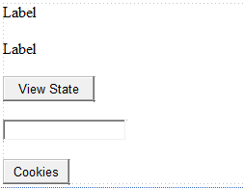
Output:
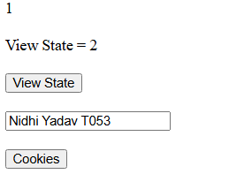

B)Create a Product Table in SQL Server and perform Insert Operation using Entity Framework Core.
Algorithm:-
Step 1:- Create Project: Open Visual Studio Create new ASP.NET Core Web App (MVC).
Step 2:-Install Packages: Open Package Manager Console and run the necessary Entity Framework Core commands.
Step 3:-Install-Package Microsoft.EntityFrameworkCore.SqlServer
Step 4:-Install-Package Microsoft.EntityFrameworkCore.Tools
Step 5:-Define Model & DbContext: Create Product.cs (Id, Name, Price) and AppDbContext.cs containing DbSet<Product> Products.
Step 6:-Configure Database Connection: Add connection string in appsettings.json and register AddDbContext in Program.cs.

Code:-
Emplye.cs:-
namespace EmplyeeCRUD.Models
{
public class Employee
{
public int ID { get; set; }
public required string Name { get; set; }
public required string Department { get; set; }
public double Salary { get; set; }

}
}
AppDbContext:-
Microsoft.EntityFrameworkCore;
using EmplyeeCRUD.Models;
namespace EmployeeCRUD.Data
{
public class AppDbContext : DbContext
{
public AppDbContext(DbContextOptions<AppDbContext> options) : base(options) { }
public DbSet<Employee> Employees { get; set; }
}
}
App.settingJson”_
{
"Logging": {
"LogLevel": {
"Default": "Information",
"Microsoft.AspNetCore": "Warning"
}
},
"AllowedHosts": "*",

"ConnectionStrings": {
"MyConnection": "Server=(localdb)\\MSSQLLocalDB;Database=EmployeeDB;""Trusted_Connection=True;TrustServerCertificate=True"
}
}
Program.cs:-
using Microsoft.AspNetCore.Builder;
using EmployeeCRUD.Data;
using Microsoft.EntityFrameworkCore;

var builder = WebApplication.CreateBuilder(args);

builder.Services.AddControllersWithViews();

builder.Services.AddDbContext<AppDbContext>(OptionsBuilderConfigurationExtensions => OptionsBuilderConfigurationExtensions.UseSqlServer(builder.Configuration.GetConnectionString("MyConnection")));

var app = builder.Build();

app.UseStaticFiles();

app.UseRouting();

app.MapControllerRoute(
name: "default",
pattern: "{controller=Home}/{action=Index}/{id?}");

app.Run();


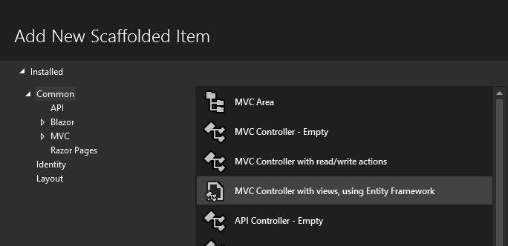
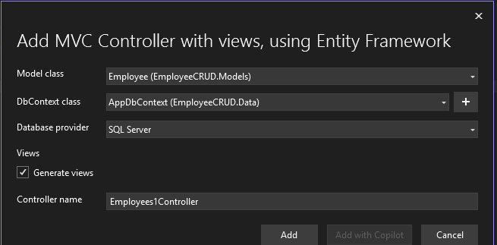
Output:-

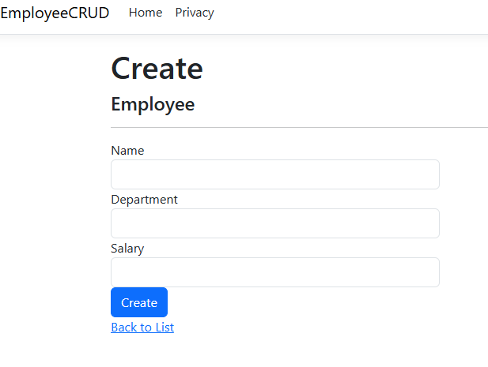
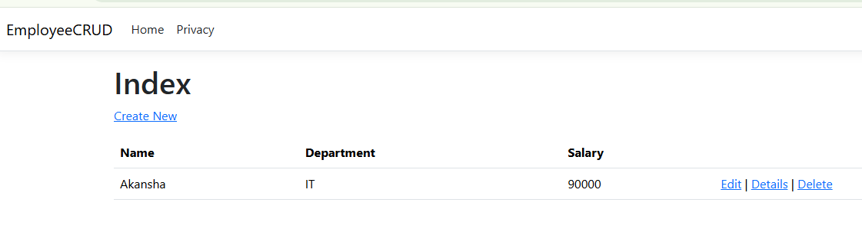

C)Develop a web application to perform CRUD Operations (Create, Read, Update, Delete) on the Employee table using EF Core.
Algorithm:-
Step 1:-Define Model: Create Employee.cs with properties (Id, Name, Department, Salary).
Step 2:-Setup DbContext: Create AppDbContext.cs with DbSet<Employee> Employees and register it inside Program.cs.
Step 3:- Apply Migrations: Run Add-Migration AddEmployeeTable followed by Update-Database in Package Manager Console.
Step 4:-Build Controller Actions: In EmployeesController.cs, implement methods for Create, Read, Update, and Delete operations.
Step 5:-Create Views: Generate corresponding Razor views under Views/Employees/ (Index, Create, Edit, Delete).
Code:-
Step 1: -Product Model (Product.cs)
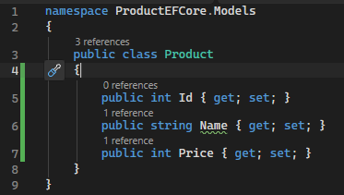
Step 2: -AppDbContext (AppDbContext.cs)
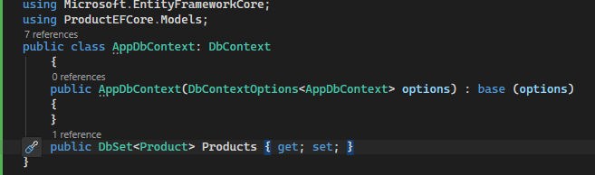
Step 3: -appsettings.json
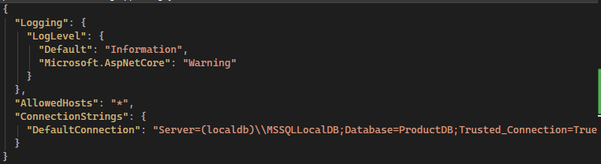
Step 4: -Program.cs
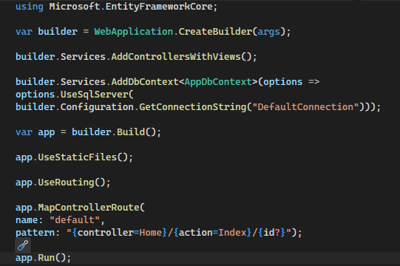
Step 6:- HomeController
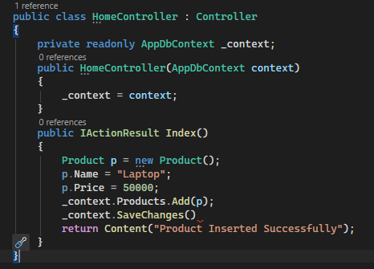
Output:-
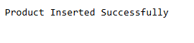


D)Authentication and Authorization in ASP.NET Core.
Algorithm:-
Step 1:-Register Auth Services: In Program.cs, add services using AddAuthentication(CookieAuthenticationDefaults.AuthenticationScheme).AddCookie(...) and AddAuthorization().
Step 2:-Configure Pipeline: Add app.UseAuthentication() before app.UseAuthorization() in Program.cs.
Step 3:-Build Login Logic: In HomeController.cs, validate user credentials, create a ClaimsIdentity, and call await HttpContext.SignInAsync(...).
Step 4:-Protect Route: Add the [Authorize] attribute directly above the Secure() action method.
Code:-
program.cs
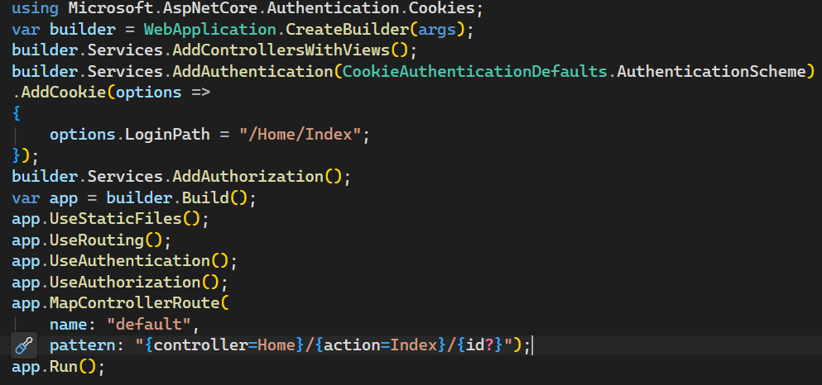
homecontroller.cs
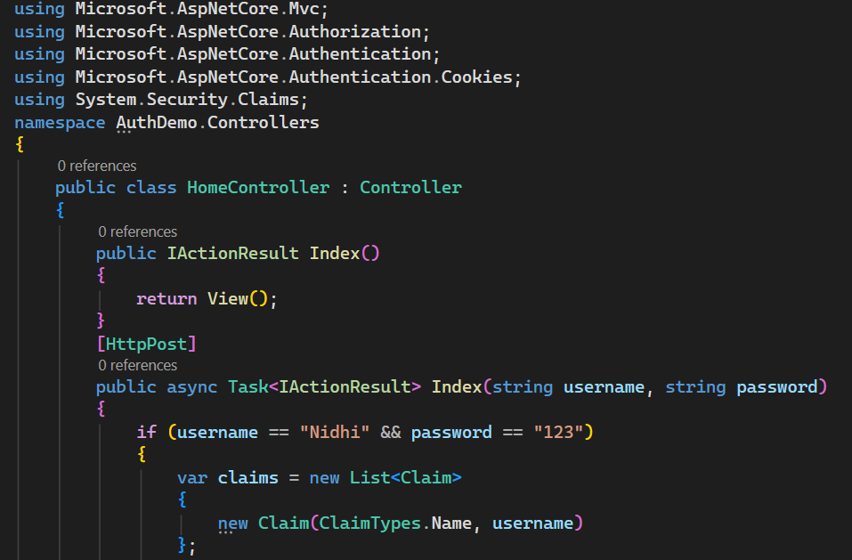
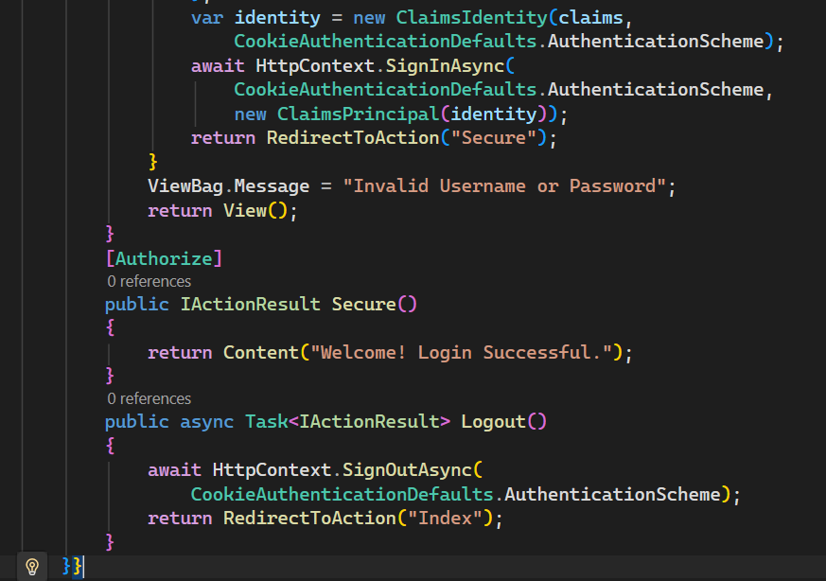
index.cshtml
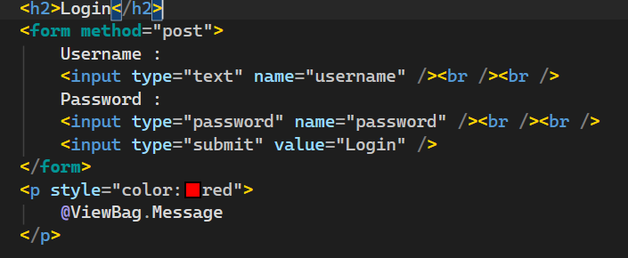
Output:-
